Connor Murray

Taranpreet Kaur

Nitika Dhawan

VOICE

Capstone Project Documentation Submission Format 1

Project Proposal: 1

Client Profile: 1

Team Profile: 2

Existing System Description 2

System Feasibility & Risks 2

User Stories: 2

Project Requirements 2

Use Case Diagram. 2

Domain Class Diagram. 3

Project Environment setup: 3

Sprint 1: 3

Use Case Description: 4

Boundary Cases (Rainy Day Paths) Descriptions: 4

Use Case Narrative and Low-Res Wireframse: 4

Design Class Diagram (DCD) -Or Equivalent 4

Code Quality 4

# Project Proposal:

## Client Profile:

**What is VOICE?**

* Voice for deaf and hard of hearing children is an organization that develops and implements programs and services, encompassing family support, public education, and advocacy for deaf children. Voice has connected hundreds of families together who are affected by hearing loss. It has become one of the largest support organizations of its kind.

Voice offers multiple programs for parents, educators, teens, children, and newly arriving families constantly. Voice works through programs of advocacy support and education to connect those with hearing loss and ensure success in their lives. - (voicefordeafkids.com)

**Voice’s Mission:**

**VOICE for deaf and hard of hearing children is committed to:**

* + *Advocating on behalf of deaf and hard of hearing children and their families*
  + *Supporting deaf and hard of hearing children and their families through supplying access to information, education, mentoring, and self-advocacy skills training*
  + *Educating the public that deaf and hard of hearing children can learn to listen and speak.*

**System Environment:**

* + **Consists of very personal information, medical records, and medical conditions some might not want to express to others at first click.**
  + **Informality of contacting members through email, Facebook, and other communication software.**
  + **Meeting and comparing families together to supply more support for each other's children.**

**Contact Information for VOICE**

**Email:** [admin@voicefordeafkids.com](mailto:admin@voicefordeafkids.com)

**Phone Number: Private**

**CharityID:** Charity #123609364 RR 0001

**Address:** 478 Dundas St. West, P.O Box 30045

Oakville, Ontario

L6H 6Y3

**All volunteers, no staff. Main point of contact is Gillian, taking** [**admin@voicefordeafkids.com**](mailto:admin@voicefordeafkids.com)

## Team Profile:

|  |  |
| --- | --- |
| **Connor Murray**   * **Product Owner** * **Backend & Lead Frontend** | **Product owners interact with the client for updates, features questions. Stop new features from entering dev chain or adding unachievable features. Backend & Lead Frontend developer contributing to development.** |
| **Nitika Dhawan****Scrum Master**   * **Backend & Frontend** | **Scrum Master Manages the sprint backlog, conducts daily stand-up meetings, demos sprint at end of week, and sprint reflection, what can we do to fix the situations occurring.** |
| **Taranpreet Kaur**   * **Lead Backend & Frontend** | **Front end developer & Lead Backend Developer, collaborates with user interfaces, designing overall interface, searching, filters, and other interface features.** |

Mission Statement:

***Bring power and efficiency to all users through programming.***

## Existing System Description

* What kind of system do you use now?
  + Diagram of current system
  + Mentorship Program
  + Connect Families to Families
    - Current system consists of families reaching out through Facebook, Phone, Email, or some other communication software for the purpose of connection to another family similar in aspects such as hearing loss, children age, chapters, geolocation, and education pathway, many more.
  + Informality
    - This currently system is completely informal. Board members do not like the informality of using multiple different communication formats to receive new members.
    - This meeting each other's families through email, phone, or Facebook led to less participation between families due to informativity. Before COVID, Families attending in person meet & greets between the two families, and informality has led to less participation.
  + Resource Intense
    - This System uses the board members human resources to achieve pairing of families between children who have similarities.
    - There are many diverse types of hearing loss, and unfortunately this is a lot of human resources spent regularly in order to achieve pairing of children.
    - Many different districts or chapters that house children, for employees to correctly reach these chapter managers, it takes resources not available all the time, or things or missed increasing to less support for all families.
  + Many Different attributes of families
    - This could mean pairing children who have cochlear implants specifically together, or vice versa, pairing children who only practice ASL, or pairing families who experience both types of learning.
  + Feature Lacking
    - There is no other functionality too this system besides employees pairing families (clients) with other families currently. And all communication currently comes through different streams.
  + Newly Designed System
    - This system would be defined as a brand new newly designed system to incorporate into their current website down the line. Currently there is no system to compare this too on the market. Our system will be one of the first of its kind, this is only because it is such a specific usage.
* What kind of functionality are you looking for in a future system?
  + Communication
    - This system is purely for communication between families, professionals, and employees to families.
    - Must be discrete in terms of medical information, family information. Some families are extremely specific in terms of what information is, or they might want displayed on their account. This includes, diagnoses of families, and professional to family information unable to be shared at all.
    - Families want to be able to have profiles that have many attributes that can be searched for. This can include, Implant learning, asl learning, or a mixture of both. This is sometime that must be indexed before families can search for other families due to security. native languages, foreign languages, bilingual functionality, “this is a new family”,
    - Families searching for other similar families for searching for employees, searching for local professionals (therapists, educators, and other aid in the local area, and Advocacy directors)
    - opt out feature for families and professionals of the searching and indexing mechanic. Sometimes a family is busy and cannot have any matches.
    - Zoom Meeting Integration for families who would like to meet with each other.
    - See members who liked other members profiles or when members have been matched with other families.
    - Have chosen each other's family as an account for meeting.

Account Mechanics

* + - Families can change their information, can have multiple children with diagnoses.
    - No account deactivation unless specifically specified from the family.
    - Notification for others who have been matched for employees, then track these matched families for record keeping sake.
      * This helps for funding from the government as the funds they raise stay in this area, Kitchener waterloo, each location having its own chapter, and chapter leader.
    - Years at voice a starting point, multiple filters, multiple children. Uploading image of family.

Extras

* + - Reporting Mechanism purely for emergency scenarios where families feel in proper use of the system has been found.
    - Families can also be appointed as Ambassadors for teaching other families. These other families will usually be other families who are new into the hearing loss scene and need aid from other families with experience.
    - Auto opt out when inactive for longer than certain periods.
    - Track Virtually Meetings. Ex Calendar feature, notification for meeting
    - user friendly designs that are easy to manage and read.
    - Matching Information tracking, who matches who, when do they match, why, do they match.
    - Donation to voice integrations
    - What are chapters, and why would you like to keep track of them?
      * Yes, chapters are the separate locations between cities. We must keep track of these as they are the key to finding similar children across different cities.
    - - Ambassadors, these will be helpers for new families, native languages, foreign languages, bilingual functionality, “this is a new family.”
    - Summer camp, registration form, report of who has paid in a certain school.
      * This is a form that a summer camp for the hearing-impaired uses for registration for members every year. This same type of information collection will be used to start our user profiles.
    - Standalone website, keeping our own profiles.
      * This system will be entirely standalone to start, and later integrated with their systems.
    - Will you want to send membership notifications, events via email phone,
      * Yes, they will want notifications when a user is matched, when a professional has been matched with them or an employee. Notifications for when a family is available to be matched, or when a professional is ready to be matched.

## System Feasibility & Risks

* Misinterpreted user data, members input incorrect symbols, Unicode characters, emojis causing input fields to return errors. This would store incorrect data as well in our databases.
* Lost User data: Members would cause this by not inputting enough correct data. Example, leaving blank spaces in names, last names, emails, phones, or just blank text fields without data.
* Error Data: Any data that is incorrect, such as address does not exist, phone number area code is not real, not enough digits, postal code doesn’t exist, zip code isn’t real. Etc. etc.
* Database errors: Sometimes data is corrupted, unreadable, or jumbled to the point we need to sort and clean it before collaborating with it.
* Secure Data: This data is medical data of the patient, it’s their diagnoses, or medical condition itself. This data will have too be secured tightly, and users given the options of removal/hidden.
* Families not playing well with each other. This is the report, or flag feature to bring in an employee's attention when needed.
* Professionals not wanting to be shown across the regions as available for work.

## User Stories:

I am new parent, and I want to find other parents that have hearing impaired children.

I am a veteran parent and I want to help new parents with children and hearing loss.

I am a parent and I want to be paired with a professional

I am a new parent with a hearing-impaired child and do not know where to start.

I am a professional seeking new client.

I am an employee seeking other Ambassadors for aid.

I am a child and would like to find other kids my age with similar hearing loss.

I am an employee seeking professionals for aid.

# Project Requirements

## Use Case Diagram.

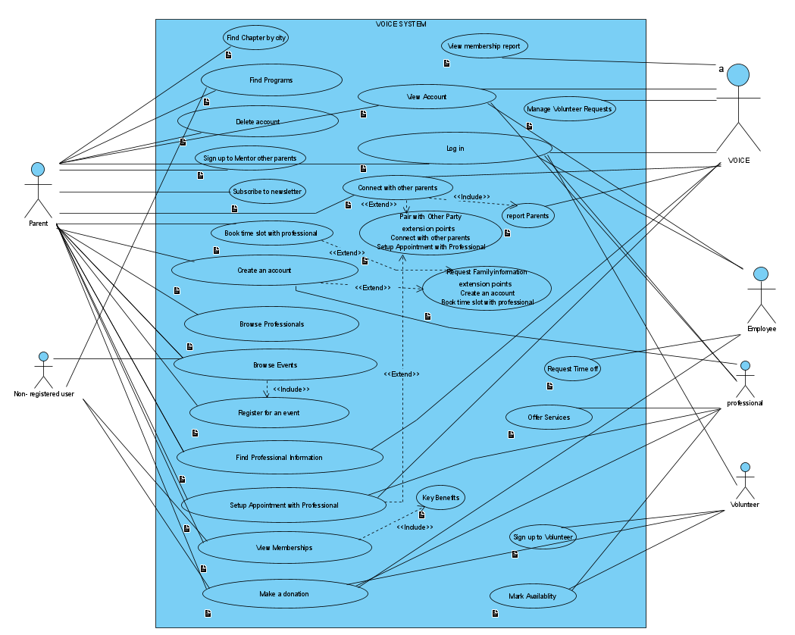

## Domain Class Diagram.

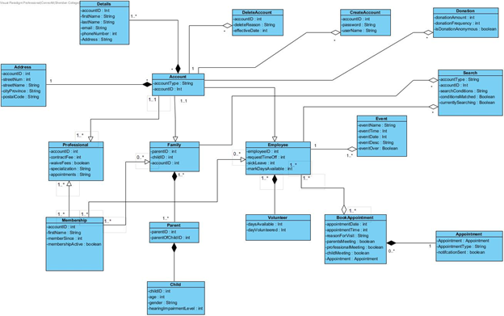

## Project Environment setup:

* Git repository - <https://github.com/HackdaNorth/VOICE_PROJECT>
* Server setup + Working Hello World Remotely –
* Docker Container --­ <https://hub.docker.com/repository/docker/murray1/voiceproject>
* docker run -dp 142.55.32.86:50131/ murray1/voiceproject on our server.
* What language? – Java, Spring boot
* What frameworks? – java web spring boot, Lombok, bootstrap
* Hello World --<https://github.com/HackdaNorth/VOICE_PROJECT/blob/main/VOICESOFTWARE/src/main/resources/templates/landingpage.html>

# Sprint 1:

Use case 1

Create Account

## Use Case Description:

Create account is amazingly simple. This will be used by the end user as they create their account on the webpage. This page takes in all information such as email, address, full name, some diagnosis information which gets a “soft encrypt” to mask these from other uses. Child information, age, DOB, city, and hobbies, description of family/child this sits right beside Login/setup. This works for employees, volunteers, professionals. Profile type is declared at sign up.

## Boundary Cases (Rainy Day Paths) Descriptions:

* Not a valid email, not a valid province, not a valid phone number, data is null, first name & last name must be valid, phone number must be ((XXX) XXX-XXXX), postal code canadian, password must be 9 characters long, , password must have one capital(A-Z), and one number(0-9),

## Use Case Narrative and Low-Res Wireframes:

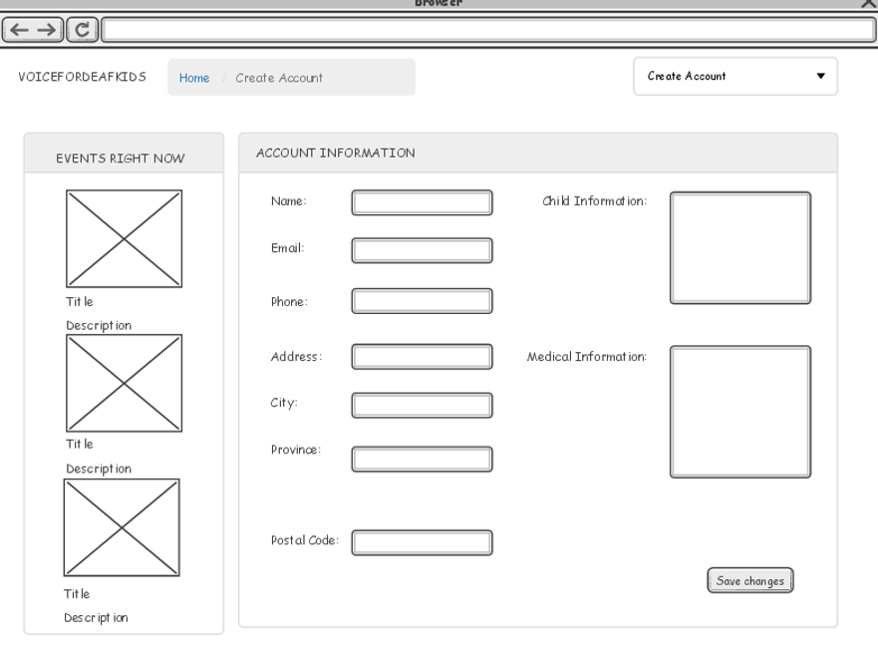 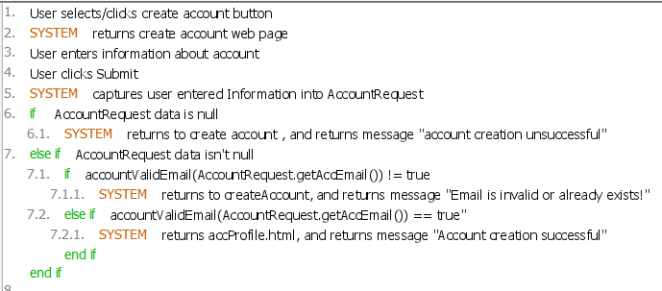

## 

## 

## Design Class Diagram (DCD) -Or Equivalent

Sprint 2:

Use case 2

**Log in.**

**Description**

Basic log in use case. End User/Employees requests to login/sign into their account for many different uses. Account management, searching for persons of interest, or requesting assistance. Log-in can be found on any page at the top right side.

**Boundary Cases**

Incorrect email, incorrect password, no such account with that email, account has been deleted, too many incorrect password attempts, backend server is currently not responding, too many requests from this IP address, please try again later.

**Use Case Narrative**

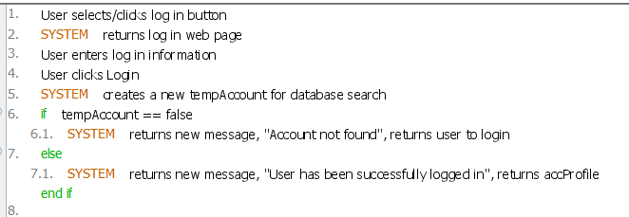

**Low-Res Wireframe**

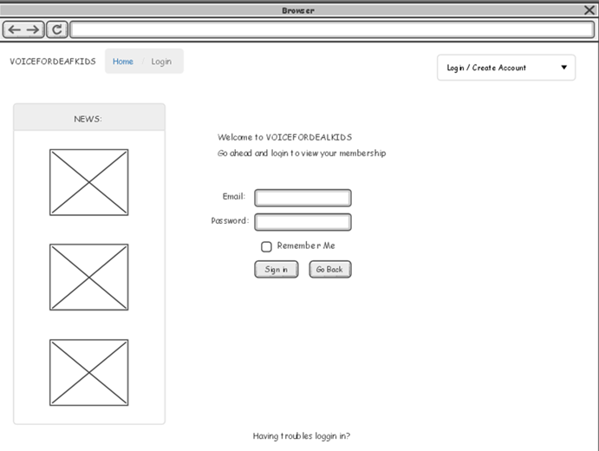

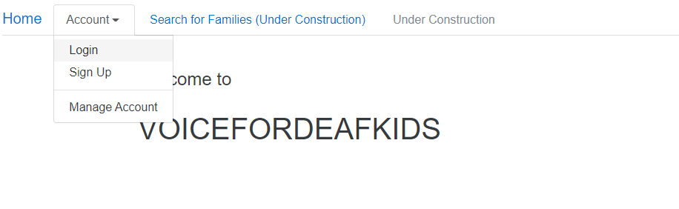 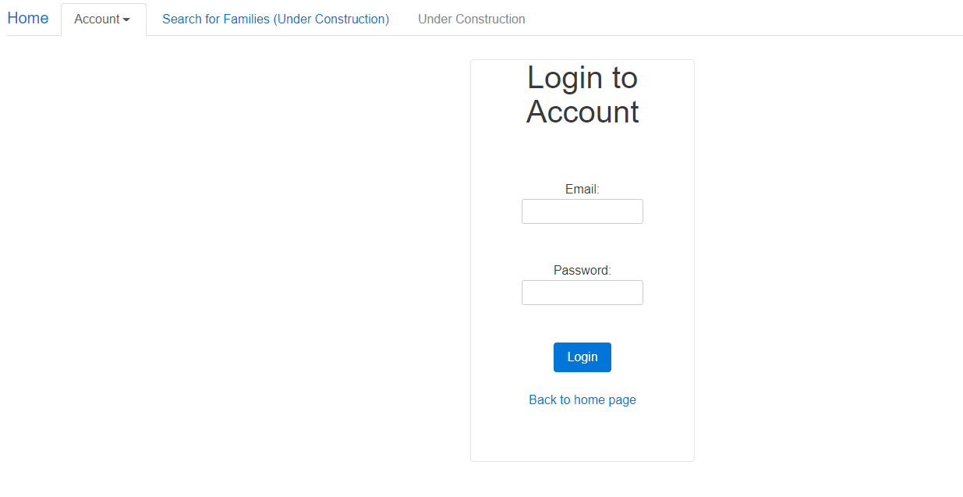

Next Steps:

USE CASE 3

**View Account**

**Description**

View account shows all profile information, depending on who is accessing it will depend on what information shows for each user. If it is the account owner; no information is restricted. Settings about the profile can be managed here. This sits on the top bar after successful login.

**Boundary Cases**

Not signed in, cannot view requested page, please try again later, the host is not responding, no account found, user deleted, account information mismatch, email is incorrect, address is incorrect, name is incorrect, no permission.

**Use Case Narrative**

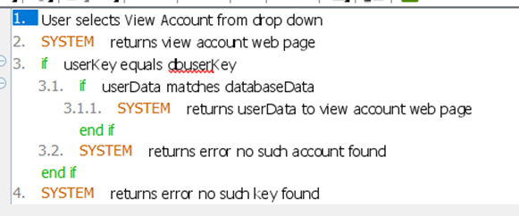

**Low-Res Wireframe**

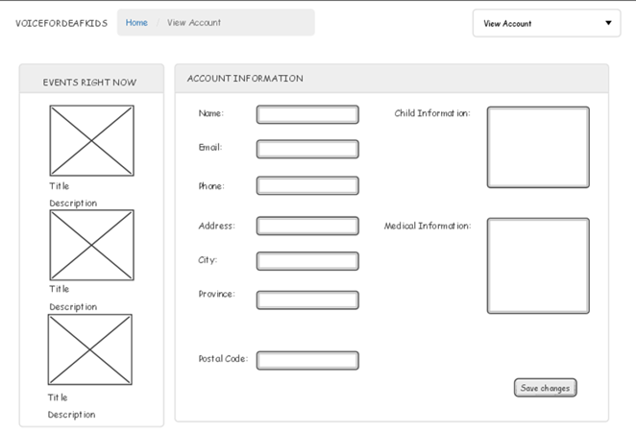

**USE CASE 4**

**Delete Account**

**Description**

Delete account, this is used by the end user when they would like to completely restrict their account from the searching queue. You may also delete it again after the fact to completely remove your account from the service. This sits on within the view account page after successful login.

**Boundary Cases**

Account cannot be deleted, account already deleted, account already removed from search que, account does not exist, backend server is not responding, please try again later, too many deletions attempts from this IP address, insufficient privilege to delete account, confirm delete, no permission.

**Use Case Narrative**

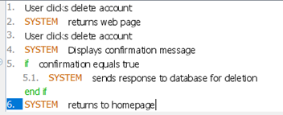

**Low-Res Wireframe**

